Image | 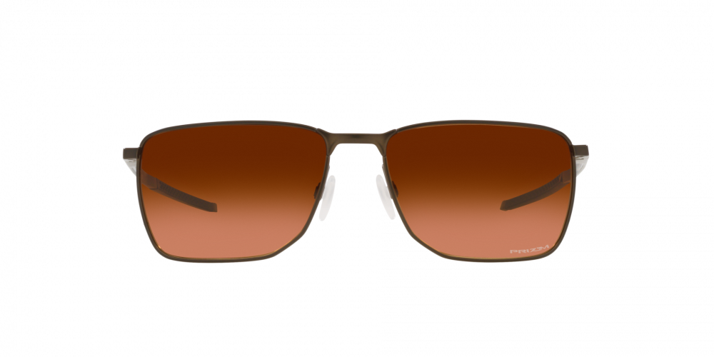
Brand | OAKLEY
Model Name | EJECTOR PEWTER
Price | RS 1499
PRODUCT DETAILS

